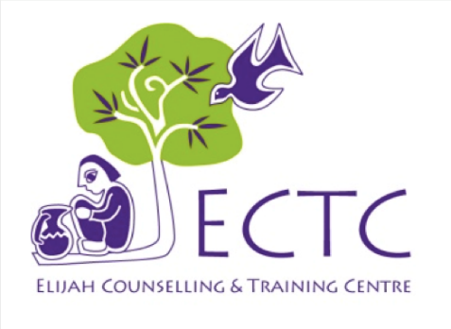  Praise Points  - The Lord has faithfully blessed the training in Kanchanpur on 24th-28th of September 2017. There were altogether sixteen participants, including five pastors and church leaders. The training was ‘Basic Pastoral Care Training, week II.  - We mentioned in our September prayer letter that the government of Kavre district had approved the project extension of “Community based program.” We are delighted to tell you that the government of Sindupalchok, chautara has also approved the same project. Therefore, be glad and rejoice in the Lord your God (Joel 2:23).  - Praise be to our God for He has stretched His hand to bless ECTC. He has provided all the requirements that are needed to run the organization.  - Praise be to our God for giving us such a wonderful and committed staff. Their work, faithfulness, unity and caring enables ECTC to be an even stronger base from which to share God’s love.  - All honor and glory goes to our Almighty God. For He has opened the giving heart of all donors to help the people who are in need of counselling. Thank you for your generosity and fulfilling the command of God, (Deuteronomy 15:11 there will always be poor people in the land. Therefore I command you to be openhanded toward your fellow Israelites who are needy and poor in your land).  - Thank you for your prayers for sister Jenny’s research paper which has now been handed in. Also give thanks for the opportunity three of them from ECTC have to do more research.  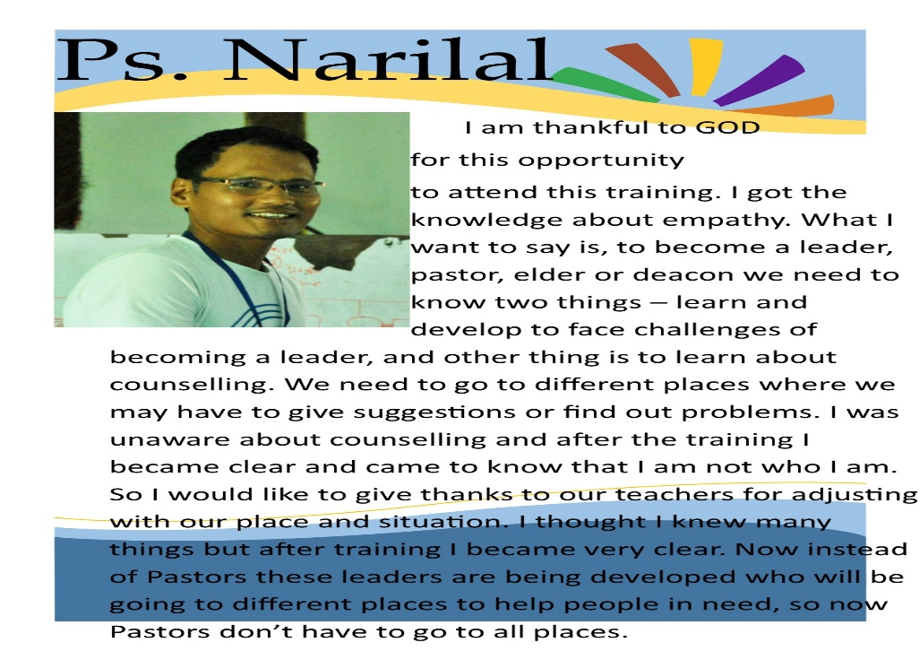  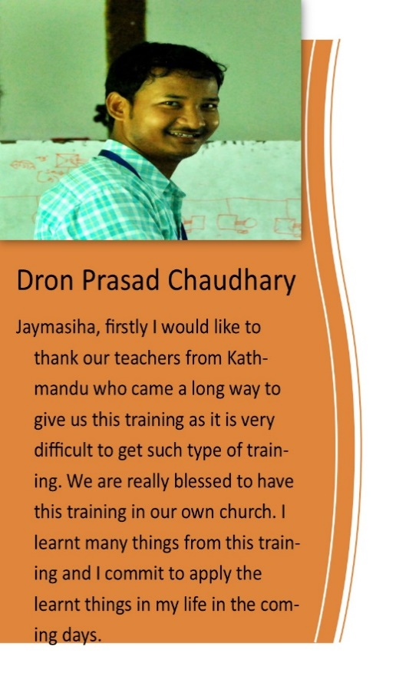 | October-2017  Prayer Letter  Thank You for your PRAYER !  Prayer Needs  - Renewal of agreement between ECTC and government of Lalitpur is still in process, so please do pray that the work shall be done within this month.  - Please do pray for the upcoming two Basic Pastoral Care Training, week II and week 1, which will be held in Tansen and Chitwan.  - ECTC has proposed to organized a SYIS training-workshop on Mid-December 2017. So, please do pray for the both preparation and participants.  - As you know that ECTC aims to build a community of psychologically and socially stable people, in both health and community setting. So, please pray that the Lord may guide all the working committees, boards, employees, donors and volunteers to work together to accomplish ECTC vision and mission, so that the Kingdom of God be exalted.  - Please do pray for the good health of ECTC staff and volunteers. You may be aware that many people are affected by the dust pollution of Kathmandu valley. We have also suffered many times from fever, headache, sinus, dust allergies, and asthma etc.  - Let us continue to pray for Dr. Irmgard. As we all know that she has gone to Germany for her home assignment from 12th August until February 2018.  - Sister Jenny has asked to pray for her as she is preparing to teach more about counselling supervision both at ECTC and in Kathmandu university.  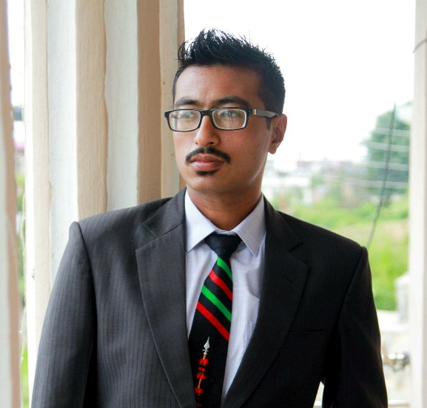  - Please pray that God will use our research findings to build significant relationships, change policies and improve areas of mental health here in Nepal.  A Short Story from ROCHAK  Tandukar  After I joined ECTC,  I have been  working in two districts; Sindhupalchok- where the highest number of people died during the devastating earthquake in 2015 and Kabhrepalanchok- which is ranked third with most injured people and most of the houses damaged.
During my visit to these districts, I had an opportunity to talk with different people and was blessed. In our conversation, I came to know that the people were aware of the need of counselling and taking it as significant. They have shared about many suicidal case that they have seen and heard and also shared that the counselling skills would help who are still in trauma, grief and other mental problems.
As I came to know that they were so excited to hear about counselling and ready to be trained. Maximum people of cities and villages are still not aware of counselling and its need. I hope people will understand the importance of counselling before it’s too late. Thank You.
Once again, Thank You !
With prayer,
ECTC family and Barnabas Baraily

Please Note: should you no longer wish to receive this letter, please inform us on info@ectc.nepal

